700

1. 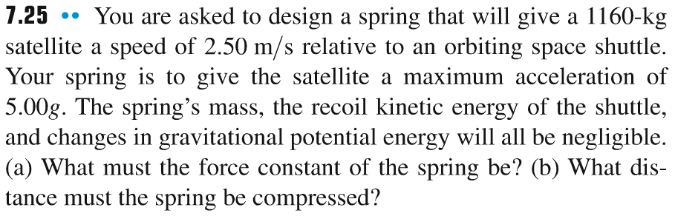

5g

1. 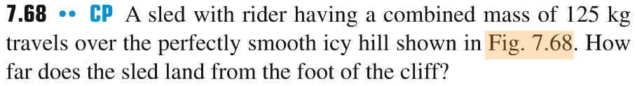

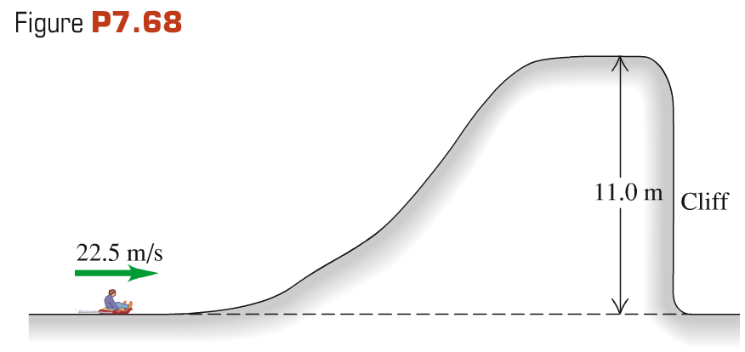

7.00

15 m/s

Block of mass 10 kg (starting from rest) slides down the ramp inclined at an angle θ above horizontal. Block moves the distance 7 m along the ramp and at the end of it encounters a spring with the force constant 1200 N/m compressing it by 35 cm.

(a) Find the angle θ if the ramp is frictionless.

(a) Find the angle θ if the coefficient of kinetic friction between the block and the ramp is 0.15.

